Project Development Phase
Model Performance Test
Date | 3 October 2026
Team ID | SWTID-2026-5226
Project Name | Import Data using Transform Maps (Spreadsheet) - ServiceNow
Maximum Marks

Model Performance Testing:
Project team shall fill the following information in model performance testing template.
S.No. | Parameter | Values | Screenshot
1. | Model Summary | ServiceNow data management setup that imports employee records from a spreadsheet using an Import Set Table and a Transform Map.  Note : Records are created or updated if the data matches correctly, otherwise an error is shown. | 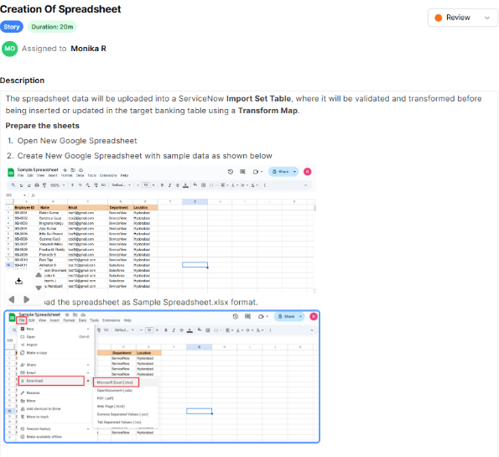
2. | Target Table | Custom table Employee Test (u_employee_test) with String fields: Employee ID, Employee Name, Email, Department and Location. | 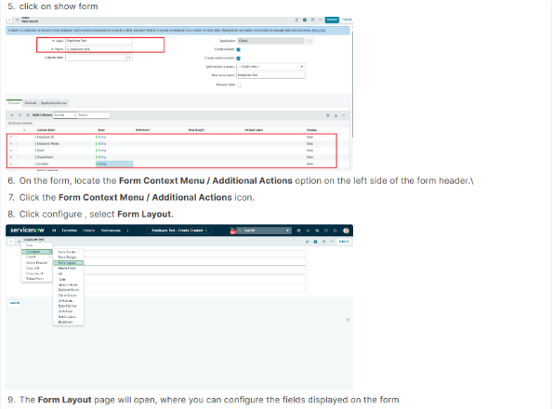
3. | Import Set Table | Employee Import (u_employee_import) is a temporary staging table that holds the uploaded spreadsheet data before it is validated and transformed. | 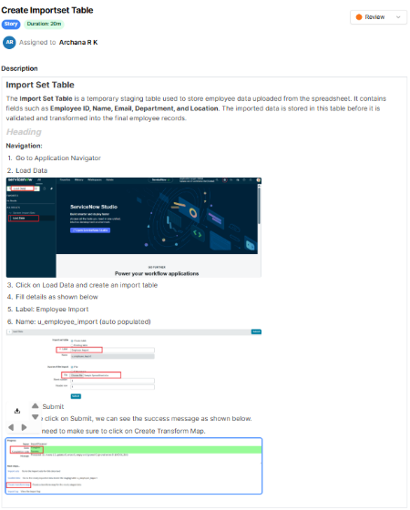
4. | Transform Map | Sample Spreadsheet Import maps Employee Import (source) to Employee Test (target) using Auto Map Matching fields. | 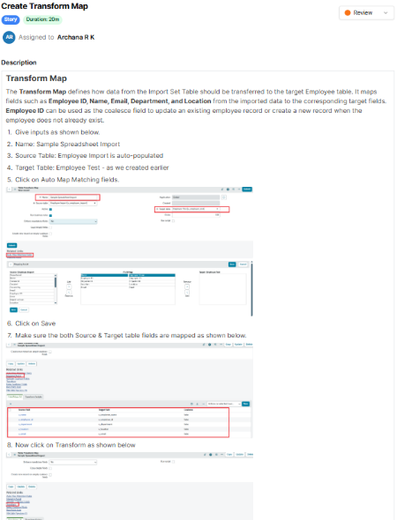
5. | Transform & Validate | All imported records were created in the Employee Test table. Required fields (Employee ID, Name, Email) were checked and list columns rearranged. | 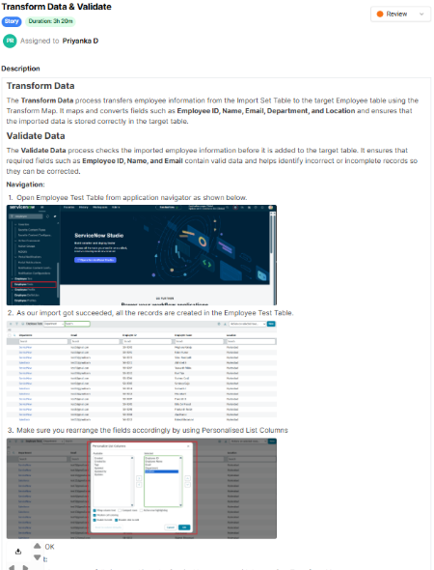
6. | Coalesce (Duplicate Handling) | Employee ID set as the coalesce field so existing records are updated instead of duplicated. | 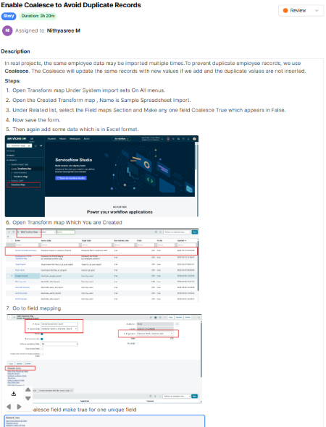
7. | Transform History Results | First re-import: 4 rows processed, 2 inserted (new IDs) and 2 updated (changed Name / Email).  Same file re-imported: 0 inserted, 0 updated, 4 ignored, confirming no duplicates are created. | 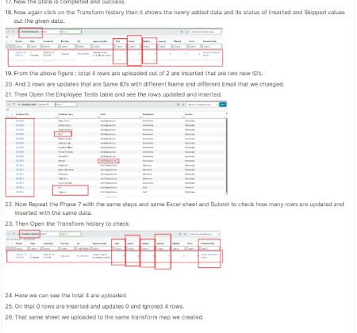
8. | Report | Pie chart report Employees by Department on the Employee Test table, grouped by Department with Count aggregation. | 